CHILDREN`S MENU
Brunch served 10am – 11:45am
Cumberland Sausage Butty £6.50
Bacon Butty (GF*) £6.50
Children’s breakfast (GF*)
bacon (1 slice), fried egg, beans, a slice of toast £5.50
Brown/White toast with butter (GF*) £2.75
add beans £1.25
Toasted Fruit Teacake with butter £2.95
Waffle with maple syrup £6.50

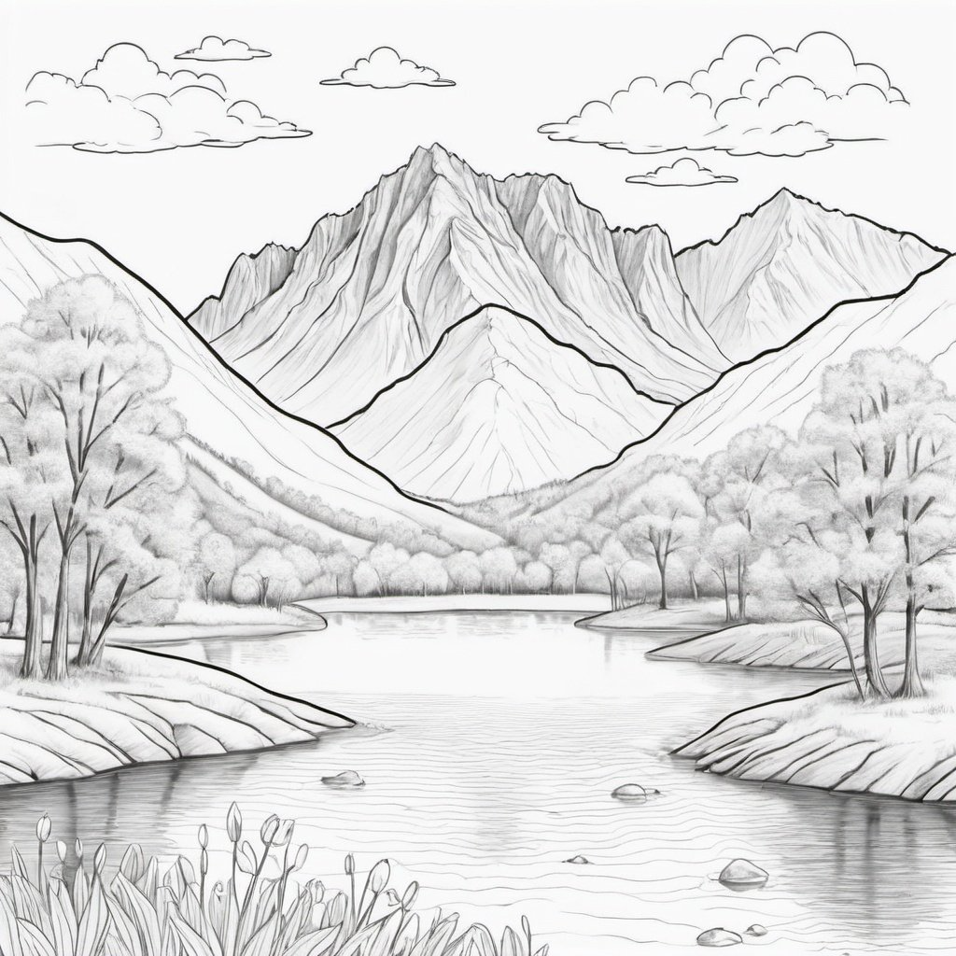
Lunch served 12pm – 4pm
MAIN MEALS
Homemade Soup of the Day (GF*) £4.00
A cup of soup served with bread & butter
Home-made Margherita Pizza (V/VE*) £6.00
add Pepperoni/Ham £1.00
Cumberland sausage, fries & peas £6.00
Mac & Cheese (V) £4.50
add crispy bacon £1.00
Cheese or ham sandwich (GF*) £4.00
On white or brown bread with cucumber fingers
add a bag of crisps £1.50

SWEET TREATS
Small tub of English Lakes ice-cream £3.50
Selection of homemade cakes from £2.85

