LUNCH MENU
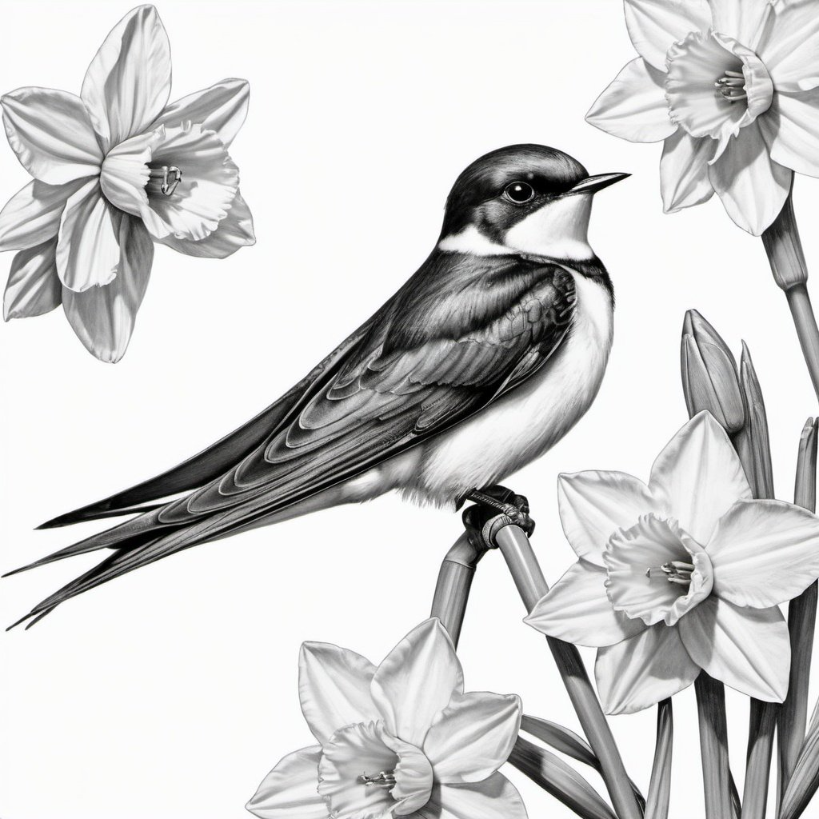
12PM – 4PM
Please make us aware of any allergies or intolerances when ordering. A full list of allergens is available on request.
V – Vegetarian; VE – Vegan; GF – Gluten Free
The * denotes that a dish may need to be altered to suit a particular dietary requirement upon request.

Lunch

Soup of the Day (VE, GF*) £6.50
Freshly prepared soup with toasted sourdough & butter
Cumbrian Venison Burger £14.00
Cartmel Valley venison burger on a pretzel bun, Brockhole tomato chutney, slaw,
smoked streaky bacon, blue cheese, skinny fries
Swap your skinny fries for rosemary, parmesan & truffle fries £1.00
Pulled Pork Bun (GF*) £14.00
Homemade pulled pork on a pretzel bun, slaw, caramelised apple butter, skinny fries
Add blue cheese £1.00
Swap your skinny fries for rosemary, parmesan & truffle fries £1.00
Mac & Cheese (V) £9.00
Macaroni in a rich cheesy sauce, parmesan & herb crumb
Add Pulled Pork £3.00
Add Smoked Streaky Bacon £3.00
Moroccan Spiced Chicken Sarnie (GF*) £11.00
Moroccan spiced chicken thighs, rustic ciabatta bun, slaw, harissa & mint yoghurt, skinny fries
Swap your skinny fries for rosemary, parmesan & truffle fries £1.00
Asian-Style Noodle Bowl
Rice noodles & stir fry vegetables, Thai broth, chilli, coriander, toasted sesame seeds
With Thai Fishcakes £13.00
Or
With Crispy Tofu (GF,VE) £12.00
Falafel Salad (VE) £12.00
Falafel, wild rocket, pomegranate seeds, cherry tomatoes, olives, red onions, salted cucumber,
mint & vegan yoghurt dressing

Artisan Pizza
12pm – 4:00pm (takeaways available)

Margherita (V/VE*) £11.50
San Marzano tomato sauce, mozzarella, buffalo mozzarella, cherry tomatoes, fresh basil, oregano
Wild Mushroom (V/VE*) £13.50
Wild Mushrooms, San Marzano tomato sauce, mozzarella, truffle oil, wild rocket, parmesan shavings
Cumbrian Lamb £14.50
Lamb Kofta, San Marzano sauce, mozzarella, harissa, red onion, salted cucumber, mint & coriander dressing
Pepperoni £13.50
Pepperoni, San Marzano tomato sauce, mozzarella, chilli-infused honey, wild rocket, oregano

Sides
Skinny fries £3.50
Rosemary, parmesan & truffle fries £4.50
Cup of home-made soup £3.50

DRINKS MENU

Hot Drinks
Espresso (Double) £3.00
Americano £3.00
Flat White £3.30
Latte £3.30
Cappuccino £3.30
Mocha £3.50
Decaffeinated coffee available for all drinks
Hot Chocolate £3.50
Gourmet* Hot Chocolate £4.50
Babyccino £2.00
Children’s Hot Chocolate £2.50
Children’s Gourmet* Hot Chocolate £3.50
(*With Cream & marshmallows)
Extras
Shot of coffee £1.35
Flavoured syrup £0.50
(Vanilla, Caramel, Hazelnut, Gingerbread)
Oat/Soya milk £0.50
Flake £0.70
Cream & marshmallows £1.00
Twining’s Tea
English Breakfast £2.60
Decaffeinated £2.60
Earl Grey £2.80
Red Bush £2.80
Peppermint £2.80
Green Tea £2.80
SOFT DRINKS
Coca Cola £2.95
Diet Coke £2.75
Fresh Apple/Orange £2.75
Cawston Press
Rhubarb & Apple £2.95
Ginger Beer £2.95
Elderflower & Lemon £2.95
San Pellegrino
Limonata £2.95
Aranciata £2.95
Harrogate Mineral Water
Still (750ml/330ml) £3.90/£2.50
Sparkling (750ml/330ml) £3.90/£2.50
Children’s Drinks
Juice Cartons
Orange £1.80
Apple £1.80
Ribena £1.80
Glass of milk £2.00
Local Craft Beer/Lager
Served from 11am
Bowness Bay Brewery (All 500ml bottles)
Lakes Lager (5%) £6.50
Swan Blonde (4%) £6.50
Swan Gold (4.2%) £6.50
Swan Free Craft Lager (0.5%) £6.50
Hawkshead Brewery (All draft)
Half Pint Pint
Helles Lager (4.3%) £3.50 £6.00
Brockhole Pale Ale (4%) £3.50 £6.00
Celtic Marshes Summer
Berry Cider (4.0%) £3.50 £6.00

WinE
Served from 11am
Prosecco (200ml) £8.75
House White (187ml) £7.75
House Red (187ml) £7.75
House Rosé (187ml) £7.75

For our full selection of wines and spirits ask for our Bar and Wine menu
Cakes & Sweet Treats
We always have a range of cakes/traybakes on offer, as well as freshly baked scones & tubs of English Lakes ice-cream.
For those of you with a sweet tooth, please look at our cake display cabinet, or ask your server for the choice on offer today!

